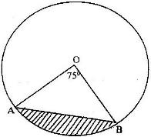
1. The figure below represents a circle a diameter 28 cm with a sector subtending an angle of 75⁰ at the centre.

Find the area of the shaded segment to 4 significant figures
(a) <PST
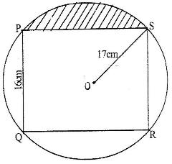
2. The figure below represents a rectangle PQRS inscribed in a circle centre 0 and radius 17 cm. PQ = 16 cm.

Calculate
  - The length PS of the rectangle
  - The angle POS
  - The area of the shaded region
3. In the figure below, BT is a tangent to the circle at B. AXCT and BXD are
straight lines. AX = 6 cm, CT = 8 cm, BX = 4.8 cm and XD = 5 cm.
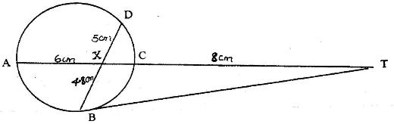

Find the length of
(a) XC
(b) BT
4. The figure below shows two circles each of radius 7 cm, with centers at X and Y. The circles touch each other at point Q.
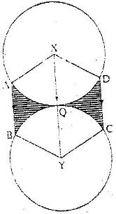

Given that <AXD = <BYC = 120⁰ and lines AB, XQY and DC are parallel, calculate the area of:
a) Minor sector XAQD (Take π ²²/₇)
b) The trapezium XABY
c) The shaded regions.
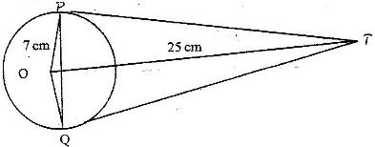
5. The figure below shows a circle, centre, O of radius 7 cm. TP and TQ are tangents to the circle at points P and Q respectively. OT =25 cm.

Calculate the length of the chord PQ

